**Hidden Charge**

**1.Introduction**

An unknown point charge *Q* is fixed in a region of space. Electrons launched parallel to the *z* axis far from the charge will scatter electrostatically off of the fixed charge and strike a detecting screen. It is possible learn about the details of the hidden charge by varying the initial kinetic energy as well as the initial *x*i and *y*i coordinates of the electron beam and measuring the final coordinates *x*f and *y*f of where an electron strikes a finite flat screen perpendicular to the *z* axis and located at *z* = 0.

It is useful to know the Rutherford scattering formula,

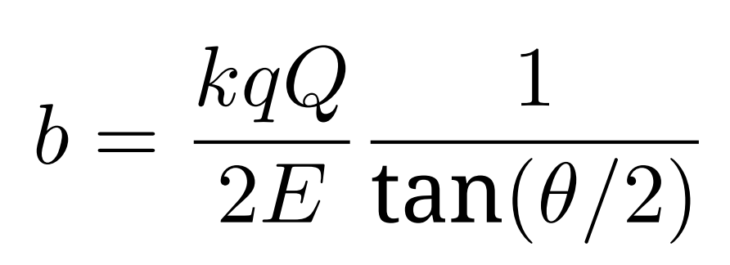

where *b* is the impact parameter, *E* is the energy of the electron, *q* = *−*1*.*602 *×* 10*−*19C is the charge of the electron, *k* = 8*.*99 *×* 109 Nm2 /C2 , and *θ* is the scattering angle. The impact parameter is defined as the closest approach of the electron to the target, assuming that the electron were unaffected by the target and hence would move in a straight line; the scattering angle is angle between the original velocity vector of the electron far from the target and the final velocity vector of the electron far from the target after scattering. 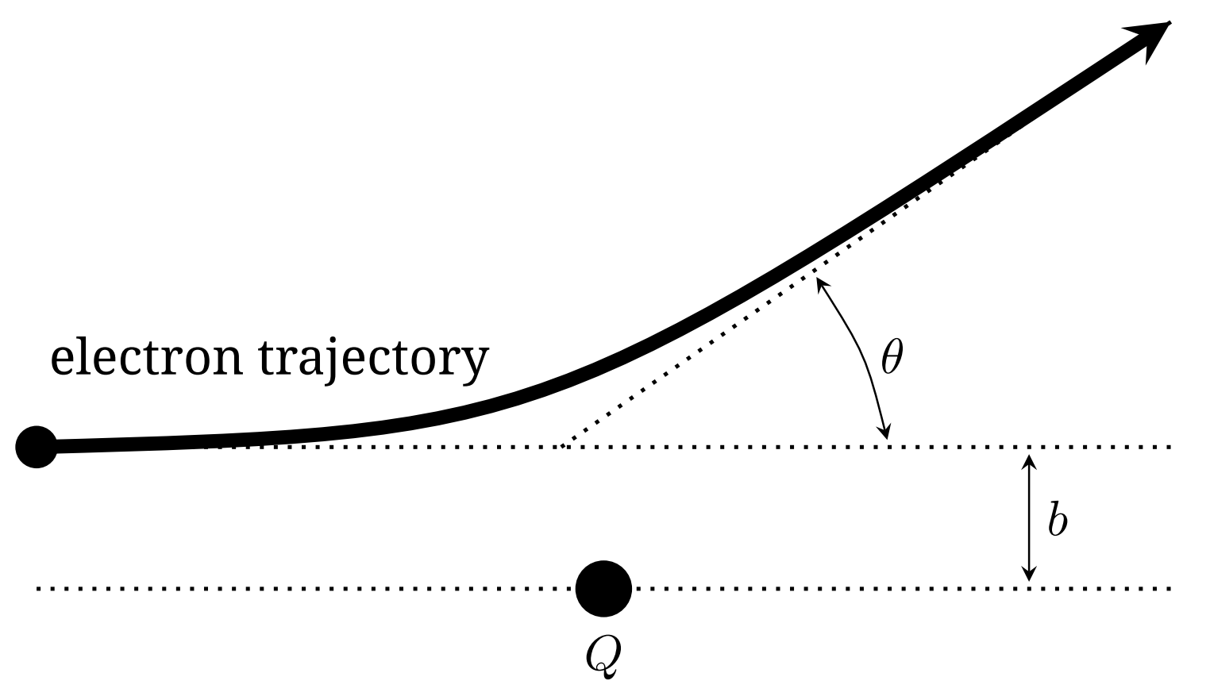

**2. Task**

The task is to determine the position (*xQ, yQ, zQ*) and also the magnitude and sign of the fixed charge *Q*, as precisely as possible. You should provide rough, order of magnitude error estimates on these results. There is Gaussian error associated with initial beam location that

is on the order of 0*.*5 mm.

As with all experiments, you must provide clearly labelled tables of data, clearly labelled graphs, and sufficient formulae derivations to make it clear what you have measured, and how you are deriving your results.

**3. Program Interface**

The program asks for an accelerating voltage with the prompt

Beam accelerating voltage in V:

Enter a number between 1 and 10000, and press **return**. The program then asks for the initial launch coordinates, starting with *x*i , with the prompt

x-coordinate of the electron beam in cm:

Enter a number between -20 and 20 and then press **return**. Finally, the program asks for *y*i , with the prompt

y-coordinate of the electron beam in cm:

Enter a number between -20 and 20 and then press **return**. If you enter an invalid number for any of these three, the program will prompt you with

Invalid entry.

and will then prompt you for the value again, reminding you of the allowed limits.

After the three numbers have been entered, the program will output

Electron beam fired with parameters (x, y, V) =

and it will restate your entered values, and then

Electron detected at (x, y) =

and give the screen location of the detected electron.

However, if the electron misses the finite size screen, you will be told

Electron not detected...

The program then repeats, allowing you to enter in a new set of initial coordinates.

隱藏的電荷

**1.**介紹

一未知點電荷 *Q* 固定在空間某區。平行於 *z* 軸由遠方射入的電子會被此固定電荷靜電散射後打到偵測屏。可以藉由改變電子束的初始動能和初始位置座標 *x*i 和 *y*i 並測量電子撞擊到垂直於 *z* 軸的

平坦屏幕上的最終座標 *x*f 和 *y*f 。屏幕處定為 *z* = 0.

下列拉塞福散射公式是有用的，



此處 *b* 是撞擊參數, *E* 是電子的能量, *q* = *−*1*.*602 *×* 10*−*19C 是電子的帶電量, *k* = 8*.*99 *×* 10*9* Nm*2* /C*2*, 和*θ* 是散射角. 撞擊參數定義為：假設電子不受靶影響而直線前進時，電子到靶的最接近距

離，散射角是電子在接近靶時的初速和遠離靶後的末速的夾角。



**2.** 任務

決定固定電荷 *Q* 的正負，大小和位置 (*xQ, yQ, zQ*)，越精確越好。也必須提供這些結果大致的不確定度估計。初始射線位置的高斯不確定度為 0*.*5 mm。

所有實驗都要清楚列出有標題的數據表，有標題的作圖，足夠的公式和推導說明你測量什麼和如何導出結果。

**3. Program Interface**

程式會顯示下列訊息

Beam accelerating voltage in V:

要求你輸入加速電壓。輸入的數值必須介於 1 和 10000 之間，記得按 **return** 鍵。接下來程式會顯示下列訊息

x-coordinate of the electron beam in cm:

要求你輸入初始的發射座標，先從 *x*i 開始。輸入的數值必須介於 *−*20 和 20 之間，記得按 **return** 鍵。最後程式會顯示下列訊息

y-coordinate of the electron beam in cm:

要求你輸入 *y*i，輸入的數值必須介於*−*20 和 20 之間，記得按**return** 鍵。如果你輸入的數值不在正確的範圍內，程式會顯示下列訊

Invalid entry.

提醒你允許的數值範圍，要求你重新輸入的數值。

在你輸入上述3個數值後，程式會輸出

Electron beam fired with parameters (x, y, V) =

確認你所輸入的數值，接著顯示

Electron detected at (x, y) =

告訴你探測到的電子的螢幕位置。不過如果電子的位置超出螢幕的範圍，你會看到下列訊息

Electron not detected...

之後程式會重覆上述步驟，讓你輸入另一組初始座標。

提醒：本次实验只要求大家确定隐藏电荷的位置，如果你对其他内容感兴趣，也可以尝试着去解决。